Дунд сургуулийн ахлах ангийн өрхийн эдийн засаг-технологийн хичээлийг заах материалын хөгжил ба дүн шинжилгээ
Хураангуй
Өнөөдөр Японы дунд сургуулийн технологийн хичээлд эрчим хүчний хувиргалт хэмээх хичээл нь зайлшгүй судлах, амьдралд дээр туршигдсан шинэ хичээл болоод байгаа төдиийгүй суралцах туршлага нь чухал гэдэг нь танигдаад байна. Эрчим хүчний хувиргалтыг судалснаараа байгаль орчин , эрчим хүчний эх сурвалж хоорондын холбоо, ба технологийн хөгжлийг багтаасан байна.
Түүнчлэн технологийн үйл явцын аргазүй, эрчим хүчний хэрэглээний мэдлэгийн суурийг хамт судалдаг. Сурагчдад зөвхөн энэ чадваруудыг олж авах төдийгүй бид тэдэнд зохион бүтээх, тоног төхөөрөмжтэй харьцах чадвар дасгал, дадлагыг олгож чадна.
Цаашлаад Шинжлэх ухаан технологи, технологийн амьдрал үзүүлэх нөлөө өрхийн эдийн засгийн хичээл нь өнгөрсөн үетэй харьцуулбал ихээхэн өөрчлөгдчихөөд байна.
Энэхүү сэдэвт Дунд сургуулийн өрхийн эдийн засаг-технологийн хичээлийг заах материалын хөгжил ба дүн шинжилгээний талаар авч үзлээ. Бид хайлш хөдөлгүүрт машин, механик дүүжин цаг, 2 хөлд робот гэх мэт болон сурагчдын тоног төхөөрөмжтэй харьцах чадвар , тэдний зохион бүтээх чадварыг нэмэгдүүлэх мөн сургалтын агуулга, аргазүй , аюулгүй байдлыг эргэцүүлэн авч үзэж эрчим хүчний хувиргалтыг хичээлийн хэрэглэдэхүүн боломжийн тухай ярилцдаг.
Нэмж хэлэхэд хичээлийн хэрэглэгдэхүүний боломжийг хайж олно гэдэг нь зарим хэрэглэгдэхүүн нь цөөн хүүхэдтэй ангид дадлага ажлаар нэвтрүүлж байгаа юм. Бид сурагчдын санаа, зохион бүтээлт , өвөрмөц шинж байдлаар өргөжүүлэхийн тулд тоглоомын хэлбэр өнгө зэргийг сайжруулсан . Сурагчид багаж хэрэгслийг ашиглах , зөв зохистой хэрэглэх арга зам эзэмшихээс гадна технологийн хичээлд чухал ач холбогдолтой зүсэх, хусах , цоолох , наах арга зүйг сурах болно. Түүнчлэн бид сургалтын хэрэгслийн хөдөлгөөнд дүн шинжилгээ хийсэн.

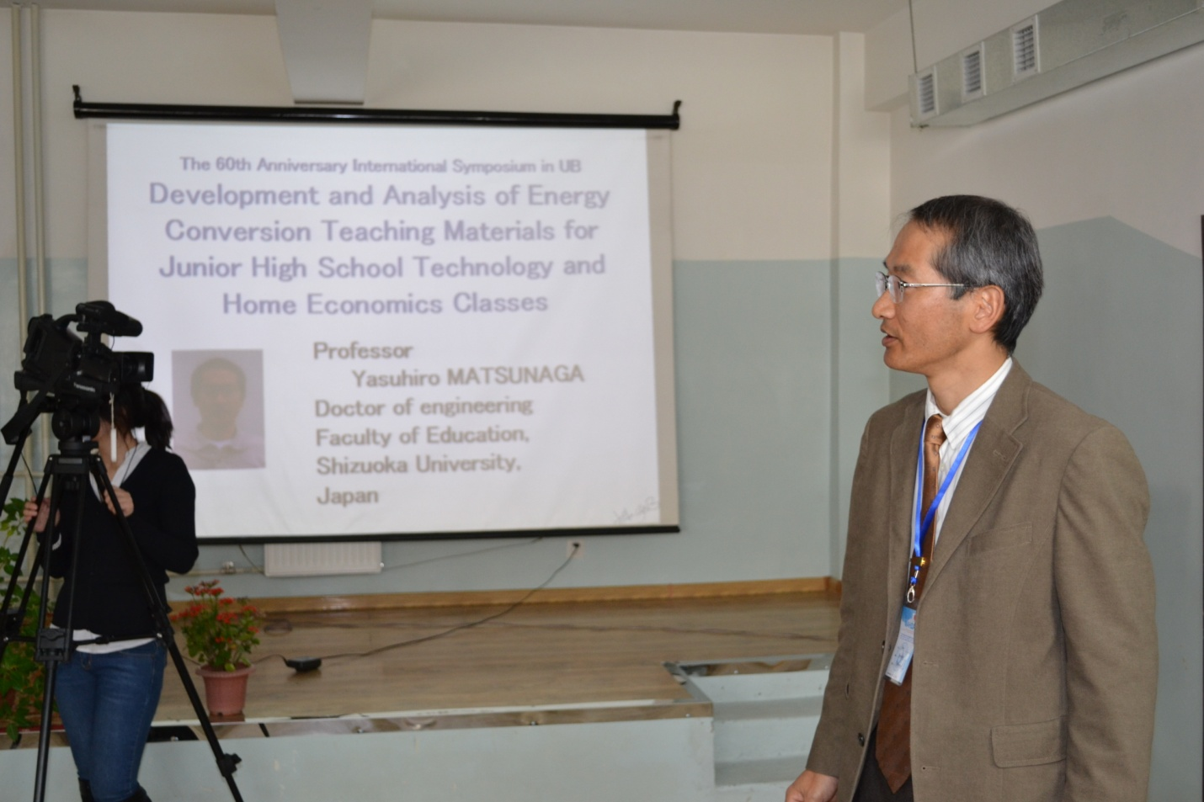

Development and Analysis of Teaching Materials for Junior High School Technology and Home Economics Classes

Yasuhiro MATSUNAGA
Yuuki ISHIGAMI
Shizuoka University, Japan

ABSTRACT
Today, for Japanese technology education courses in junior high school, the contents of "energy conversion” were made a compulsory subject newly, and practical learning and learning experience have been recognized important. Studying “energy conversion” includes the relationship between environment, energy resources and the development of technology. And it also includes the foundational knowledge and technique of processing technology and energy use. Not only do we need to make students acquire these abilities, but we should make them get creative and device abilities and practical attitudes as well. Furthermore, the science technology and life in technology and home economic education has changed largely compared with that of the past.
This paper deals with “Development and Analysis of the Energy Conversion Teaching Materials for Junior High School Technology and Home Economics Classes”. We make and improve shape memory alloy engine cars, mechanical pendulum clocks, bipedal robots, etc. to broaden creative and device ability of students, and talk about possibility as an energy conversion teaching material with considering learning contents, technique and safety. Besides this, we analyze the motion.

- INTRODUCTION
Today, for Japanese technology education courses in junior high school, the contents of "energy conversion” were made a compulsory subject newly, and practical learning and learning experience have been recognized important. Studying “energy conversion” includes the relationship between environment, energy resources and the development of technology. And it also includes the foundational knowledge and technique of processing technology and energy use. Not only do we need to make students acquire these abilities, but we should make them get creative and device abilities and practical attitudes as well. Furthermore, the science technology and life in technology and home economic education has changed largely compared with that of the past.
This paper deals with “Development and Analysis of the Energy Conversion Teaching Materials for Junior High School Technology and Home Economics Classes”. We make and improve shape memory alloy engine cars[1-2], mechanical pendulum clocks[3], bipedal robots[4], etc. to broaden creative and device ability of students, and talk about possibility as an energy conversion teaching material with considering learning contents, technique and safety.
In addition, to find the possibility as a teaching material, the materials were actually introduced in the small class for some students as a practical teaching. And we improved our toys such as changing the shape, and painting colors to expand students’ idea, creativity and originality. Through the manufacture, students can experience to use tools and acquire the way of using them, and they can also learn the way of cutting, shaving, drilling and gluing, which are really important in technology education
Besides this, we analyze the motion of the teaching materials.
- SHAPE MEMORY ALLOY ENGINE CAR
TiNi shape memory alloy (SMA) is known as a functional material generally and used for a frame of glasses, an antenna of mobile phone, etc. Reciprocating engine using a coil spring of SMA has been developed for a plant utilizing a warm drain from a factory, but we used a SMA wire and pulleys as a main element for the engine, and moreover, thermal energy caused by the temperature difference between hot water and room temperature is used as the energy source.
We developed the SMA engine car as a teaching material for learning the structure of engine, energy conversion and transmission.

2-1 OPERATING PRINCIPLE OF THE SMA ENGINE
As you see Fig 1(a), the ring-shaped SMA wire is installed between upper and lower pulleys, and the lower part of lower pulley is heated with a hot water. The part of wire that is heated with a hot water tries to turn into straight-shaped and tension symmetrically. However, since the wire is on the pulleys, it keeps standing in an unstable state. Therefore, as we give the pulleys a rotary force, symmetrical balance of temperature collapses (Fig 1(b)). Because of the difference of symmetrical temperature, the symmetrical balance of power on the pulleys collapses, and as a result, the rotary power causes among the pulleys, and they can rotate continuously.

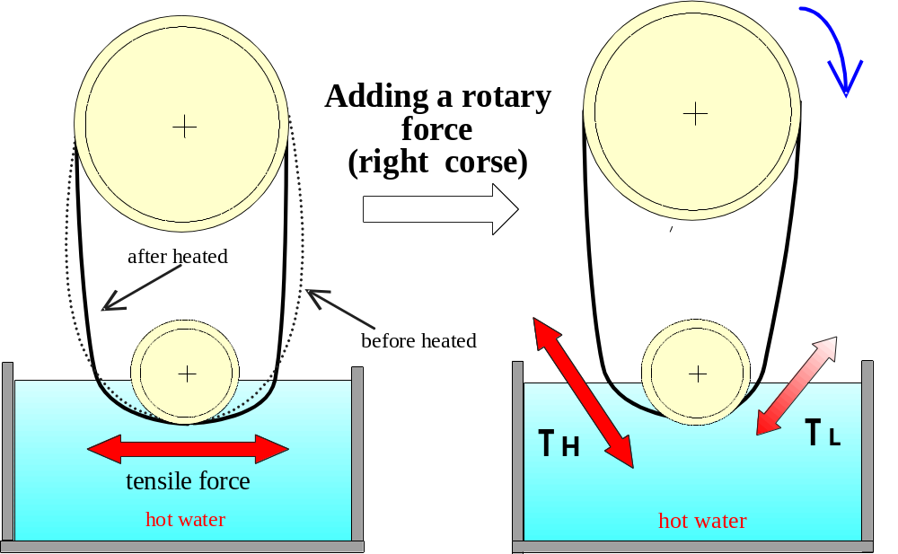
(a) (b)

Figure 1. Operating principle

2-2 IMPROVEMENTS FOR THE SMA ENGINE CAR
As you see Fig 2, we show the improved SMA engine car by use of 0.3mm diameter TiNi wire.
The engine part of type I (Fig 3 (a)) had a problem that the upper pulleys were heated by the steam caused in the vessel (for putting in a hot water), because the upper pulley is installed in flat right above the vessel. As a result, the temperature difference can’t be caused between upper pulleys and lower pulleys.
In the type II (Fig 3 (b)), the engine part is leaned about 45°from a chassis. By the improvement, we can decrease to have the upper pulleys heated, because the upper pulleys are less heated than previous one. Furthermore, the type II can move by itself in launch without receiving a rotate force.

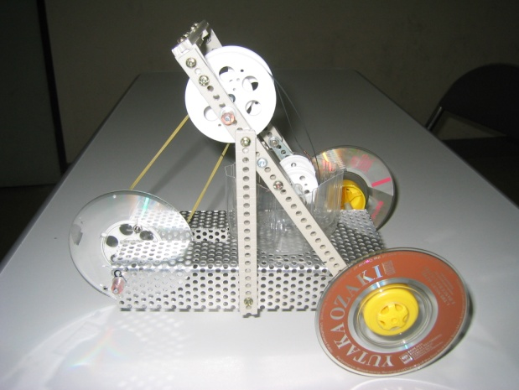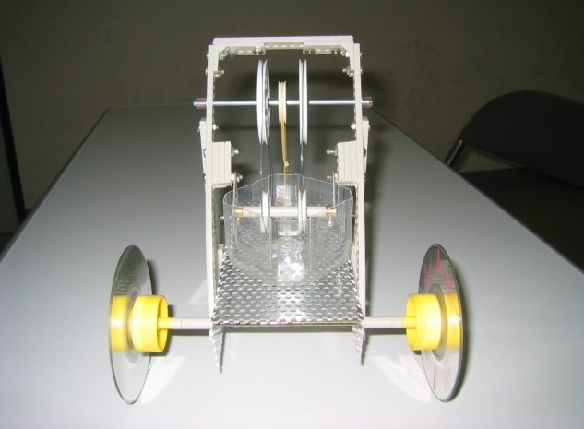
(a) Side view (b) Front view
Figure 2. Improved SMA engine car

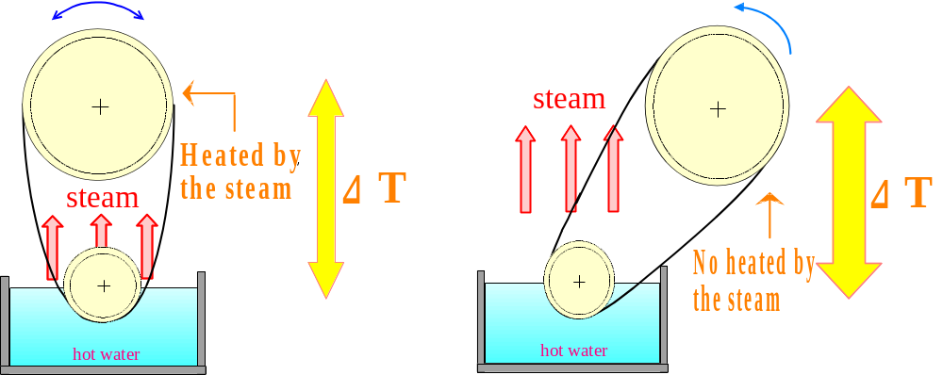
(a) Type I (b) Type II

Figure 3. Improvement of the engine part

- WOODEN MECHANICAL PENDULUM CLOCK
The movement of the pendulum clock consists of speed regulator, escapement, gears, and power source. We have developed the wooden mechanical pendulum clock as a teaching material by use of the speed regulator, escapement, and power source.

3-1 BASIC STRUCTURE OF THE PENDULUM CLOCK
The wooden mechanical pendulum clock consists of five main parts shown in Fig 4. Anchor of part A acts with part B of a special gear called escape wheel. Anchor has two nails and performs swing motion around the shaft, and two nails stop a tooth of escape wheel in turn and release it. The mechanism including escape wheel and anchor is called “Escapement” (Fig 5). During anchor swings a lap, escape wheel turns a pitch of teeth (Fig 6). Pendulum of part C is installed in the shaft of anchor and they swing together. Part D is frame supporting the shafts. In addition, a string with weight E is wound around the shaft of anchor and supplies energy that is necessary for the driving of the clock.

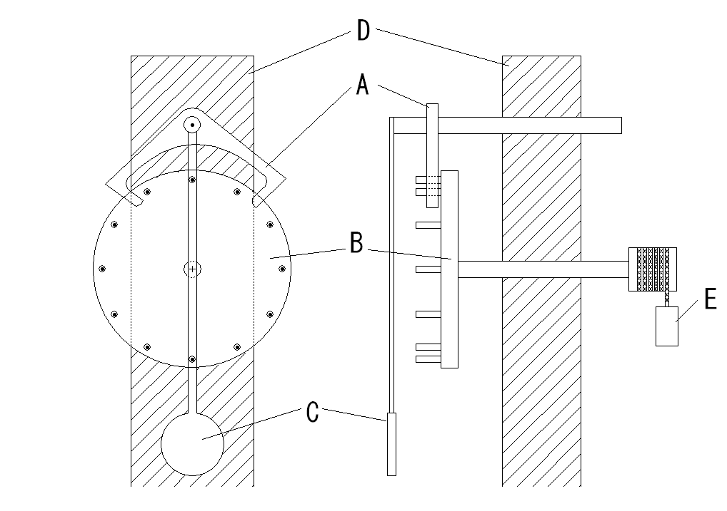
A：Anchor
B：Escape wheel
C：Pendulum
D：Flame
E：Weight

Figure4. Basic Structure of the Pendulum Clock

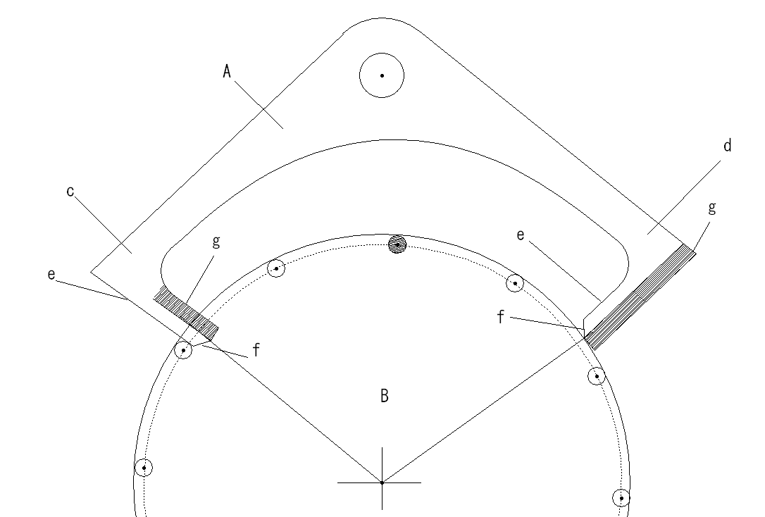
A：Anchor
B：Escape wheel
c：Input nail
d：Output nail
e：Standstill aspect
f：Shock aspect
g：Reinforced part

Figure5. Escapement

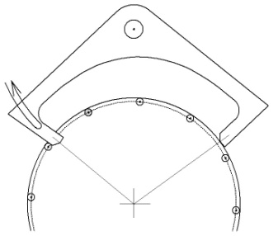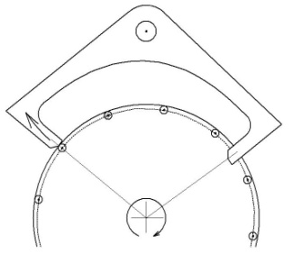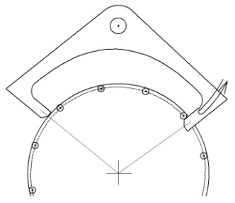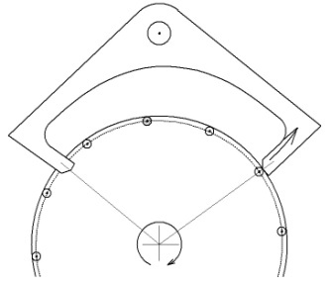
(a) Supporting motion (b) Impact (c) Supporting motion (b) Impact
of input nail of input nail of output nail of output nail

Figure6. Motion of escapement

3-2 IMPROVEMENT OF MECHANICAL PENDULUM CLOCK
We have improved the wooden mechanical pendulum clocks. The flame length was shortened, and the support of the anchor shaft was improved as shown in Fig 8. Besides this, gears and a spiral spring were got on the clock (Fig 9, Fig 10).

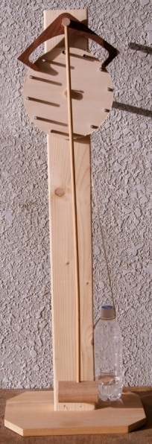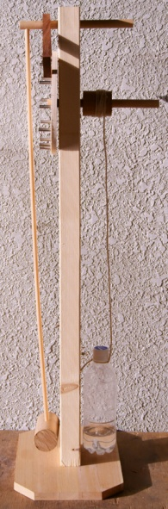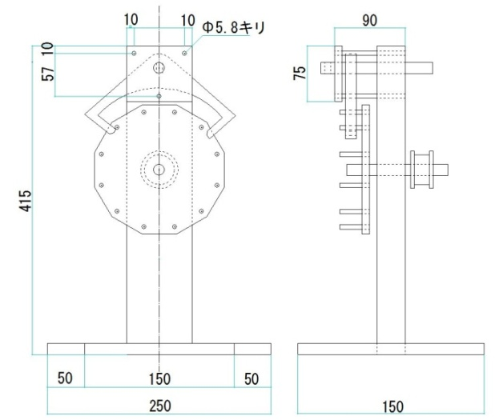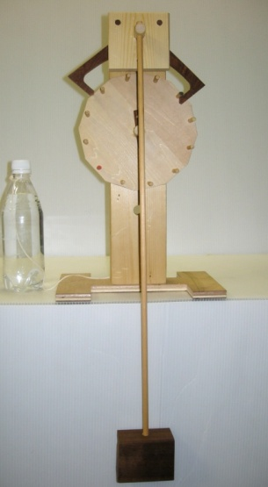

Figure7. Motion of escapement Figure8. Wall hanging type

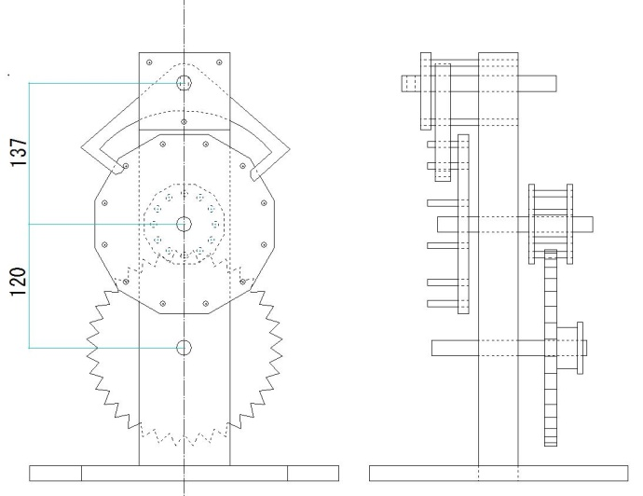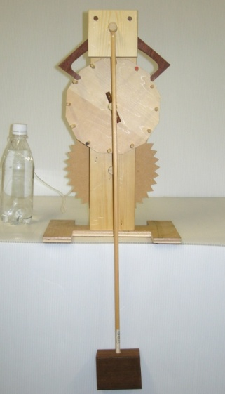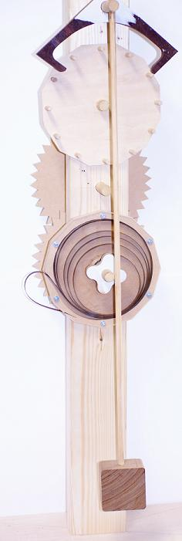

Figure9. Wall hanging type with gears Figure10. Spiral spring

- WALKING ROBOTS
In resent years, the development of the robot mainly on the bipedal robot is advancing rapidly so that it is represented by ASIMO of Honda Motor Co., Ltd. Bipedal robot comes to be sold as a toy or teaching material, and a lot of meetings by the bipedal robot such as "Akiba robot athletic meets" are held, and the robot comes to get close. We make bipedal walking robots using of servomotors as teaching materials.
We produced the waist and legs parts of bipedal walking robot with four servomotors. At first, junior high school students make these parts, and next, they make original body and arms parts by themselves.

5. CONCLUTION
We made and improved shape memory alloy engine cars, mechanical pendulum clocks, bipedal robots, etc. to broaden creative and device ability of students, and talk about possibility as an energy conversion teaching material with considering learning contents, technique and safety.

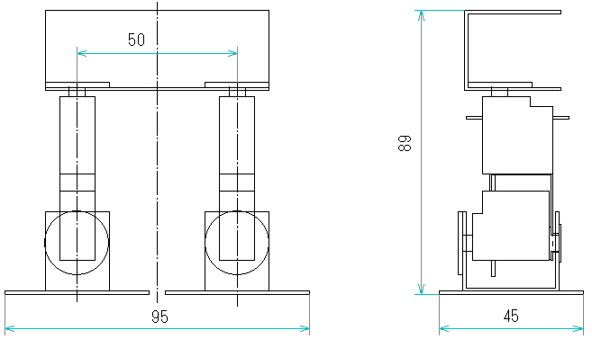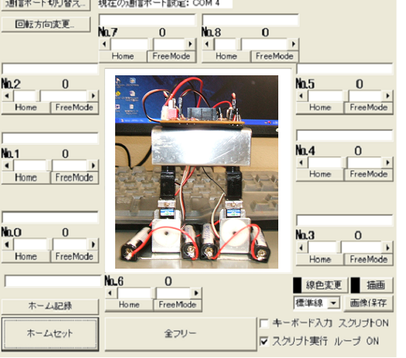

Figure11. Drawing of bipedal robot Figure12. Control panel

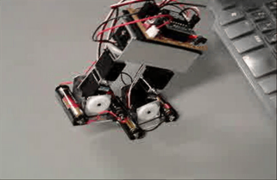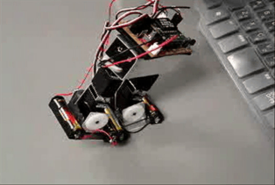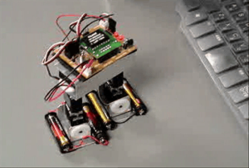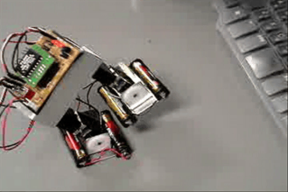
Figure12. Walking scenes

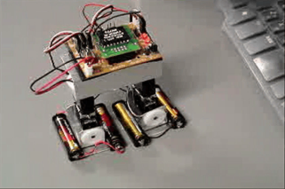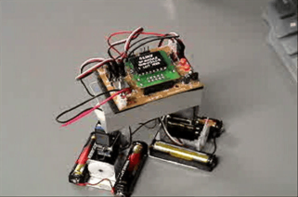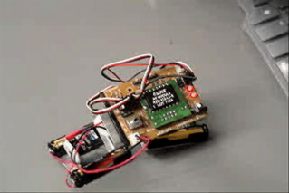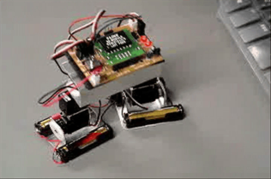
Figure13. Bow scenes

References
[1] Yasuhiro MATSUNAGA .(2004). Production of Engine Cars/Ships Using TiNi Shape Memory Alloy Wire. Journal of the Japanese Society of Technology Education, 46-2, pp.79-84
[2] Yasuhiro MATSUNAGA.(2004). Development of Engine Car Using TiNi Shape Memory Alloy Wire as a Teaching Material. Journal of the Japanese Society of Technology Education, 46-3, pp.143-149
[3] Yasuhiro MATSUNAGA.(2011). The Improvement of a Wooden Mechanical Pendulum Clock as a Teaching Material. Journal of the Japanese Society of Technology Education, 53-1, pp.17-24
[4] Yasuhiro MATSUNAGA.(2010). Study of the Bipedal Walking Model Powered by Servomotors as a Teaching Material. Journal of the Japanese Society of Technology Education, 52-2 , pp.87-94

