What’s the Right Age to Begin Music Lessons?

By Dr. Robert A. Cutietta
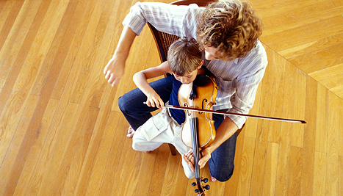
We’ve all heard the stories of famed musical prodigies, from Mozart writing his first symphony at the age of eight to Stevie Wonder signing with Motown at 11. Even if your child isn’t performing with the New York Philharmonic or the Chicago Symphony by age 11 (like violinist Midori and Herbie Hancock, respectively), your family is undoubtedly exposed to talented children in the neighborhood. Whether it’s the church preschool choir or an elementary school band concert, it seems as if parents must immerse their children in music lessons from birth if they want them to succeed, and in a way, they’re right.
That being said, parents often hear complaints from other parents that influence them to postpone music lessons until their child is older, such as “My parents forced me to play an instrument when I was young. … I hated it then and still hate it now.” In order to avoid this negative attitude, parents opt to delay music lessons until their child is older and can choose their own instrument or make the decision that they even want to play an instrument. They too are right.
These statements may seem contradictory. In reality, the issue is how you define music lessons. To better understand this, it’s important to look at the underlying reasons a parent might want their child to take music lessons.
There is a growing (and convincing) body of research that indicates a “window of opportunity” from birth to age nine for developing a musical sensibility within children. During this time, the mental structures and mechanisms associated with processing and understanding music are in the prime stages of development, making it of utmost importance to expose children in this age range to music.
The important question then is not when to start lessons, but what is the goal of music lessons for young children? For instance, very young children are not exposed to instruments in order to master them, but to gain experience and learn to develop meaningful relationships with music at a young age. If this is your goal, then the “lessons” can and should start soon after birth and certainly within the child’s first year.
These “lessons” do not have to be—in fact, at first probably shouldn’t be—very formal. A parent can serve as guide by immersing the child in a musical environment. You should help your child focus on the music with simple movement activities such as musical games, swaying or dancing while holding the baby, or singing or playing an instrument for the child.
Once the child is around age three, it may be time for more formalized “lessons.” Again, the goal is not to learn to play an instrument but to further develop skills like identifying a beat in music, identifying melody, or identifying instruments. These parent-child lessons might be any number of preschool classes run by private individuals, universities, or community centers. To decide whether or not a class is suitable for your child, make sure your goals and expectations coincide with the teacher’s.
By age five, most children have built a foundation that has prepared them for formalized music lessons. Even now, the goal of the lessons is not to become a great performer on the instrument but to further the understanding of music. Piano and violin are the two most common instruments played at this age, but others have tried the recorder, guitar, or ukulele with success.
By age 10, the child will have a variety of skills associated with their instrument of choice. They’ll also have the physical strength to try a different, bigger instrument, such as a brass or large string instrument that requires a higher level of strength and stamina. Around this time, the goal of lessons appropriately transitions from gaining experience with music to improving performance ability.
In summary, there are three answers to the question, “What age should children begin music lessons?” Informal activities with music should start soon after birth, followed by more systematic classes around age three, and lessons with the goal of learning the instrument should start between six and nine. Keep in mind that these are only guidelines; exceptions will undoubtedly occur based on the child and/or teacher. Musical experience at an early age is extremely important in a child’s developmental process. Like riding a bike or learning a language, these skills can be learned later in life, but they will never be “natural” in the way that is so important for fluid musical performance.

Dr. Robert A. Cutietta is the Dean of the University of Southern California Thornton School of Music. He is the author of “Raising Musical Kids” and a popular speaker whose areas of expertise include the middle-school learner, choral education, learning theories and the psychology of music. Additionally, he is a highly regarded musician and educator with extensive knowledge about the full range of musical talent nationally as well as internationally.

